**Program Eight Part One:**

//summary: makes a class entitled Rectangle and is used to find the width, height, area, and perimeter of a rectangle

//name: Jenna Wolf

//class: Fundamentals of Programming, CS155 - 01

//instructor: Dr. Art Kazmierczak

//date: 10/09/2023

public class Main

{

public static void main(String[] args) {

Rectangle Rec1 = new Rectangle(4, 40); //holds the Rec1 data

Rectangle Rec2 = new Rectangle(3.5, 35.9); //holds the Rec2 data

//tells the user what the program does

System.out.println("This program uses classes to find the width, height, area, and perimeter of rectangles!");

System.out.println();

//displays the data of the first rectangle

System.out.println("First Rectangle Properties:");

System.out.println("Width: " + Rec1.width);

System.out.println("Height: " + Rec1.height);

System.out.println("Area: " + Rec1.getArea());

System.out.println("Perimeter: " + Rec1.getPerimeter());

System.out.println();

//displays the data of the second rectangle

System.out.println("Second Rectangle Properties:");

System.out.println("Width: " + Rec2.width);

System.out.println("Height: " + Rec2.height);

System.out.printf("Area: %.2f", Rec2.getArea());

System.out.println();

System.out.println("Perimeter: " + Rec2.getPerimeter());

}

}

**Class:**

//Summary: Rectangle class that holds all data about a rectangle

public class Rectangle

{

double width = 1; //holds the width data and sets it to 1

double height = 1; //holds the height data and sets it to 1

//empty constructor

Rectangle(){

}

Rectangle(double w, double h) //constructor that takes the data values and sets width and height to them

{

width = w; //sets width to w

height = h; //sets height to h

}

//function that returns the area of a rectangle

double getArea(){

return width * height; //returns width times height

}

//function that returns the perimeter of a rectangle

double getPerimeter(){

return (width * 2) + (height * 2); //returns the width times 2 plus the height times 2

}

}

Output:

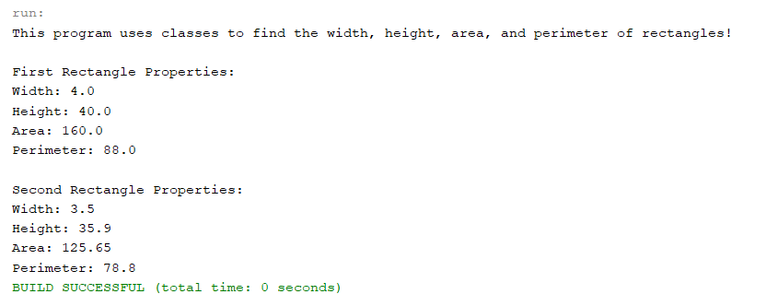

**Program Eight Part Two:**

//summary: This program uses the Gregorain Calendar class to output different dates

//name: Jenna Wolf

//class: Fundamentals of Programming, CS155 - 01

//instructor: Dr. Art Kazmierczak

//date: 10/09/2023

import java.util.GregorianCalendar; //lets the Gregorian Calendar class be used

public class Main

{

public static void main(String[] args)

{

GregorianCalendar cal = new GregorianCalendar(); //holds the cal data using the GregorainCalendar class

//tells the user what the program does

System.out.println("This program uses the GregorianCalendar to show the Year, Month, and Day.");

System.out.println();

//outputs the current year, month, and day

System.out.println("Current Year: " + cal.get(GregorianCalendar.YEAR));

System.out.println("Current Month: " + cal.get(GregorianCalendar.MONTH));

System.out.println("Current Day: " + cal.get(GregorianCalendar.DAY_OF_MONTH));

System.out.println();

//sets cal to the value given

cal.setTimeInMillis(1234567898765L);

//outputs the year, month, and day of today since January 1st, 1970

System.out.println("Time elapsed since January 1st, 1970");

System.out.println("Year: " + cal.get(GregorianCalendar.YEAR));

System.out.println("Month: " + cal.get(GregorianCalendar.MONTH));

System.out.println("Day: " + cal.get(GregorianCalendar.DAY_OF_MONTH));

}

}

Output:

